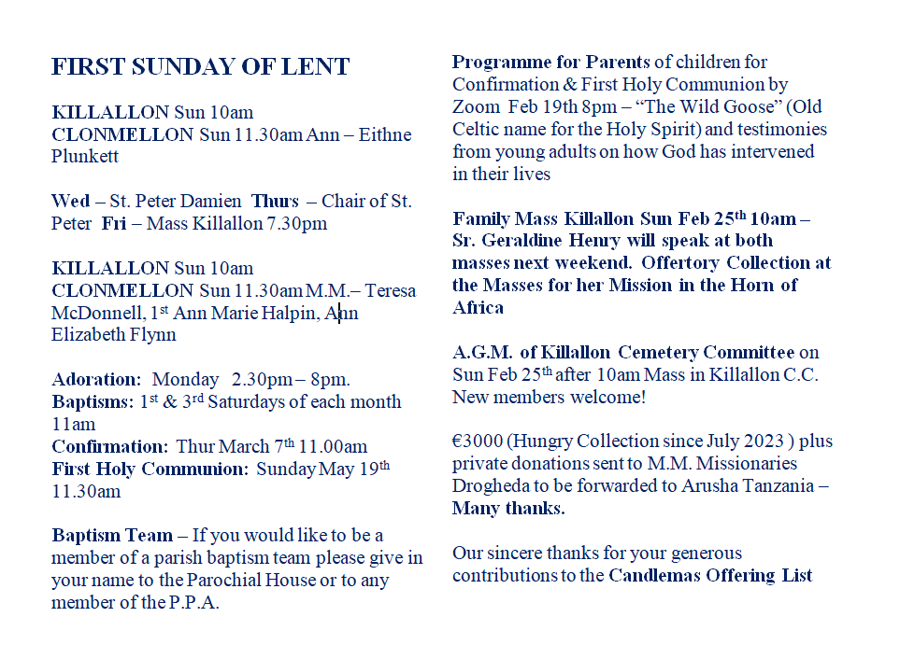

**Points to Ponder**

Even though we are no longer asked by the Church to observe the severe penances of former times, it is surely fitting that we make some form of preparation. It should be a time for personal reflection on where we stand as Christians. Only a little reflection will convince us that, there are many ways in which we fail through word and action, through our thoughts and through our failure to be the kind of people that the Gospel challenges us to be.

But our reflections should not only focus on the negative. What are the positive things which should be part and parcel of my daily life? What kind of a person am I in relation to my family, friends, working colleagues and other people with whom I come in contact? How active am I as a member of my Christian community, e.g. my parish? What difference do I make to other people’s lives? What do I do, within my limitations, to help eradicate the abuses which are part of our society? These are just some of the questions I can ask myself during these six weeks. And it is never too late to get started. Let us not rigidly think that, because Ash Wednesday has already come and gone, that I cannot start today. Remember that even those who came to the vineyard at the eleventh hour were paid the same amount. But the earlier I start the better.  
  
 